Scope, Epics and User Stories

For

*Learning Assistance System*

*Code Warriors*

# Table of Contents

Description of the problem 3

Scope 3

Key Business Requirements and Processes 4

System Context Diagram 6

**Epics**6

**User Stories**6

**Risks**8

Definitions, Acronyms, Initialisms, and Abbreviations (DAIAs) 9

**References**9

## Description of the problem

Developing a flexible learning portal where a registered user can customize and track their learning depending on their areas of interest. It is a platform of all the courses and resources where the users can interact with their co-learners and get rewards to recognize their achievements. Admin can add, delete or make any modifications to the learning portal.

## Scope

**Background**

As we all know learning is a lifelong process, but only a few people know how to plan and learn in a disciplined way to achieve their goals. Users can set and track their goals of interest through this learning portal

**Goals**

* A platform that provides the user to set and track goals, select resources of their interest from internet or Amazon’s Kindle, Netflix, or Coursera etc
* Provide rewards to the users for their accomplishment's and to motivate users
* Provide an interactive platform for the users to communicate and share thoughts

**Scalability**

The portal should be able to serve 2000 users at any given time and have the flexibility to increase the number of users by 50% per year after 1st deployment.

**Systems**

* Web Browsers: Google Chrome, Internet Explorer, Safari
* Mobile Operating Systems: Android, iOS

**Out of scope**

* No physical products sold
* Customer Care Support

**Assumptions**

* Users without an account will not be able to customize and set/track goals but they can read limited books/blogs and articles
* Only limited resources are free for the users

Site content will be only in English US

**Tasks and Deliverables**

Task 1: Requirement Analysis

Deliverable: Epics and User Stories

Task 2: Understanding of overall System

Deliverable: High-level context diagram

## Key Features and Related Business Processes

The following are the feature and process examples that relate to Learning Assistance System for the users.

* Manage Account Login Details – The system makes it easy for the user to create a new account either by logging through

1. Facebook or Gmail accounts
2. Mobile number
3. Username and password

* Implement Authentication System – An authentication system will identify the customer identity and after verification will allow the user to log in successfully
* Implement Authorization System – An authorization system will ensure that each user can access the system as per their role (user or admin).
* Provide access to different resources based upon the user’s areas of study
* Generates Dynamic Dashboards – The system will generate a user-friendly dashboard where the users can see the resources, learnings and track the status of their learnings.
* Provide the flexibility of setting the timeline for the users to accomplish the goals.
* A social network for the registered users to interact with other users where they can share their goal accomplishments and awards to trigger a healthy competition environment.
* Recognize the registered users by giving rewards such as badges, levels or in-app currency for their accomplishment
* Notifying the registered users about their status through an email
* The system should be built to support various languages.
* Allows public and private communication between users through a chat box or an email

**Business Process**

The complete flow of Learning Assistance System is as follows:

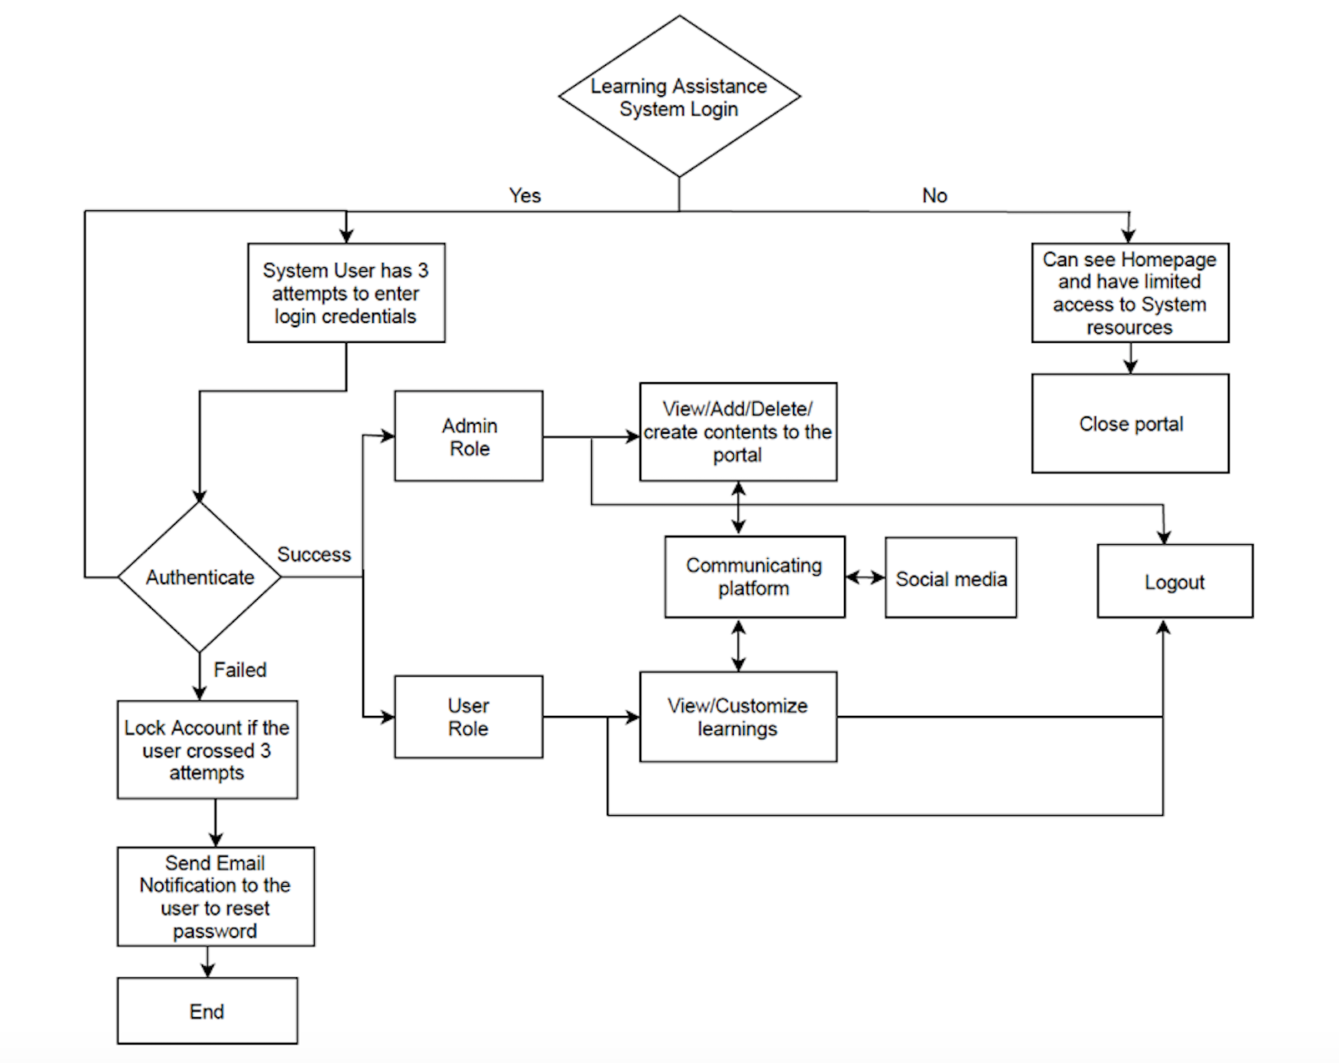

## System Context Diagram

The context diagram for Learning Assistance system is as follows:

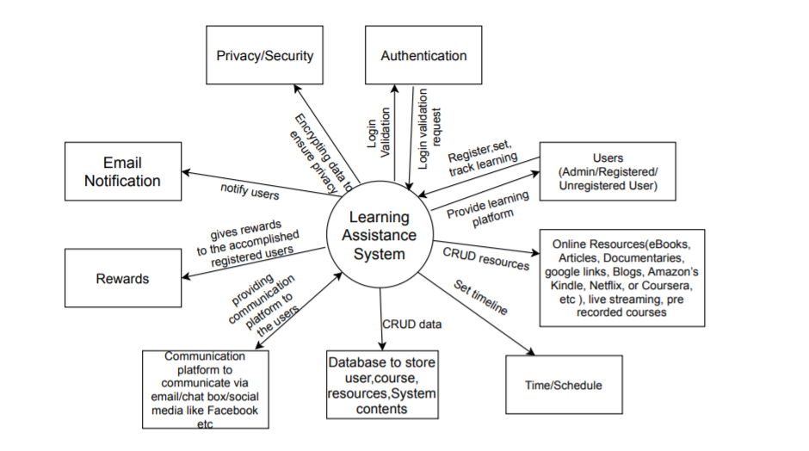

## Epics

**Epic 01**: Create a User Interface for Learning Assistance System

**User Story 01:** As a learner, I need a user-friendly home page with the following feature tabs so that it’s easy to find all the desired items

* Home
* Languages
* Areas of study
* Sources
* Goals
* Levels
* Badges
* Register
* Login
* Chat
* Support
* About Us
* Calendar and
* Download from Play Store or App Store

**Epic 02**: Create an account

**User Story 01**: As an Admin/user, I should be able to create an account with a username/ mobile number/Facebook/Gmail account and password.

**User Story 02**: As a system admin, I should be able to create an admin account and get admin access to do CRUD operation on the system contents.

**User Story 03**: As a user, I should be able to create a user account and get user access to do CRUD operation on learning.

**Epic 03**: Authentication and Authorization

**User Story 01**: As an admin, I should be able to perform CRUD operations on the system. So that I can provide all the facilities to the users after a successful login to the system.

**User Story 02**: As a user, I should be able to login successfully after entering valid login credentials and use the learning assistance system of my interest to set and track learning.

**Epic 04**: Users of the Learning Assistance System

**User Story 01**: As an unregistered user, I should be able to view the Home page but I will not be able to view the dashboard and other disabled contents until I create an account.

**User Story 02**: As a registered user, I should be able to view Homepage and have the right to access to view and use all the areas of study available in the system so that I can organize what I want to learn by topic. I should also be able to set and track my learnings from the dashboard with my badges, levels, in-app currency, or other creative rewards included.

**Epic 05**: Manage resources

**User Story 01**: As an admin, I should be able to view, add or delete resources in the dashboard. Resources can be online resources like e-books, blogs, articles, documentaries, live streaming, prerecorded courses, etc. I should give only limited resources as free to non-registered users but can give access to all resources to the registered users.

**User Story 02**: As a registered user, I should be able to use all the resources available in the system and can customize according to my interest.

**User Story 03**: As a non-registered user, I have access only to limited resources available in the system.

**Epic 06**: Manage rewards to motivate the users

**User Story 01**: As an admin, I should be able to view, add, delete or modify rewards in the dashboard. Rewards can be badges, levels, in-app currency, and other creative rewards. Also, I can give awards only to the registered users if they have achieved any goals.

**User Story 02**: As a registered user, I should be able to get the rewards as a recognition of my achievement. I should be able to make use of these rewards to open other courses for my learning and, I should be able to share my accomplishments with other users.

**Epic 07**: Social network to interact with other co-learners

**User Story 01**: As an admin, I should be able to provide a communication platform to the users and ensure the privacy of their data.

**User Story 02**: As a registered user, I should be able to communicate with other users through a chat box or email.

**User Story 03**: As a non-registered user, I am not able to communicate with other users.

## Risks

**Technical**

* Users may experience difficulties communicating with each other due to having dependencies on third-party applications such as Facebook, Gmail, etc. Problems can occur during live streaming on mobile devices
* Failure to identify complex functionalities and time required to develop those functionalities.

**Financial**

* Mobile device users will have hit on their data plan and usage limit, as applicable, while accessing the system and using Netflix or other media services.
* Wrong budget estimation
* Failure to meet the requirements in defined timelines
* Yearly expenses to scale the system to cater to the newly added user’s increase.

**External risk**

* Changes needed in the system based upon the technological advancements
* Changing customer product strategy and priority
* Government rule changes

**Operational Risks**

Formation of a well-defined Support/Ops team to resolve the issues/failures if any

Definitive escalation path

Meet SLAs (Service Level Agreement)

Intermittent communication in the team

## Definitions, Acronyms, Initialisms, and Abbreviations (DAIAs)

The table below contains a collection of Definitions, Acronyms, Initialisms, and Abbreviations specific of this project.

|  |  |  |
| --- | --- | --- |
| **DAIAs** | **Term** | **Definition** |
| *CRUD* | *CRUD Create, Read, Update and Delete* | These are the four basic functions of persistent storage. Also, each letter in the acronym can refer to all functions executed in relational database applications and mapped to a standard HTTP method and SQL statement |

## References

* <https://www.mountaingoatsoftware.com/agile/user-stories>
* <https://en.wikipedia.org/wiki/Scalability>
* <https://msdn.microsoft.com/en-us/library/bb896744.aspx#anchor9>
* <https://www.modernanalyst.com/Careers/InterviewQuestions/tabid/128/ID/1433/What-is-a-Context-Diagram-and-what-are-the-benefits-of-creating-one.aspx>
* <https://www.lucidchart.com/pages/business-process-mapping>
* https://blog.turbonomic.com/blog/on-technology/cloud-scalability-scale-vs-scale